Vol VII Book 01 — Federal Application-Aware Networking — CMDB Reconciliation & Asset Identity
  - Populating the CMDB from M365 and Azure, and reconciling it to the authoritative IPAM/DDI join key (CM-8)
SSA Cloud Services Team
2026-07-12 15:00 ET
INTERNAL — NOT FOR PUBLIC DISTRIBUTION

Draft Proposal — Subject to Review
Developed by the CSI Team (Cloud Services Infrastructure); not yet reviewed or approved by the SSA CIO Office, OIS, or leadership. Date Code: 2026-07-12 15:00 ET
Series Context — Volume VII Book 01. The foundation of the coordination layer: before ServiceNow can route control work over M365 and Azure, its CMDB must know what exists — and that knowledge must reconcile to the authoritative IPAM/DDI asset identity established in Vol I Book 01, not compete with it. This book is the CM-8 join that makes every downstream compliance task addressable to a real, single asset.

What This Document Addresses
A compliance task is only as good as the asset it names. “Remediate the exposed storage account” is actionable; “remediate something in one of three subscriptions” is not. Coordination therefore begins with inventory: the CMDB must hold every M365 and Azure asset a control claim can attach to, keyed to an identity an assessor can trace end to end.
This book covers how the CMDB is populated from the two cloud surfaces, and — the load-bearing part — how it is reconciled to the authoritative asset identity so the CMDB never becomes a second, competing source of truth. The naming plane (IPAM/DDI, Vol I Book 01) owns identity; the CMDB is its workflow projection.

The Reconciliation Model
The CMDB is a projection, not a source of truth. Discovery and connectors populate the CMDB; the authoritative IPAM/DDI record governs identity. Where they disagree, the CMDB is wrong by definition and the disagreement is itself a finding. This is the CM-8 join key discipline (Vol I Book 01, Vol III Book 03): one authoritative name/address per asset, and every inventory — ServiceNow, Defender, Azure Resource Graph, Purview — reconciled to it.
Layer | Owns | Realized by | Reconciles to
Naming & addressing plane (truth) | Authoritative asset identity — name, address, DNS/IPAM record | IPAM/DDI (Vol I Book 01) | — (it is the SSOT)
Cloud-native inventory | Per-surface resource state | M365 Graph; Azure Resource Graph; Defender inventory | The naming plane, at ingest
CMDB (coordination projection) | Workflow-addressable CI records + relationships | ServiceNow Discovery / Service Graph Connectors | The naming plane, on every reconcile pass
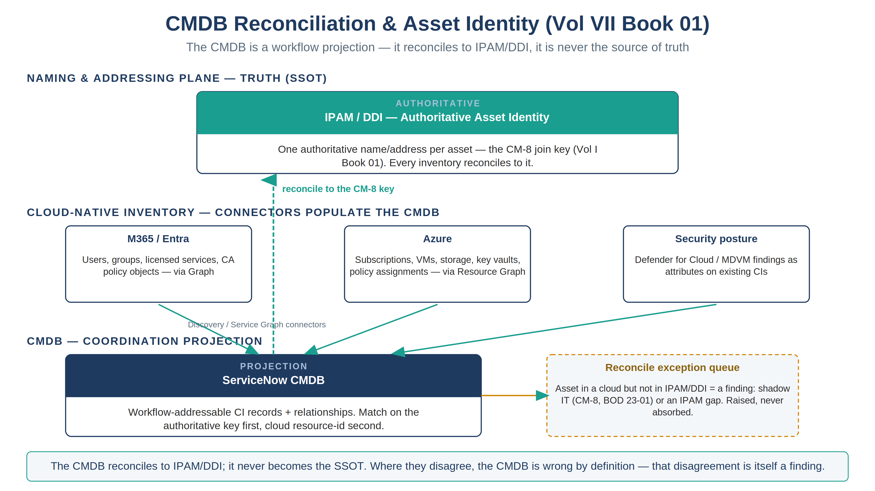
The reconciliation model — cloud-native inventories populate the CMDB, which reconciles up to the authoritative IPAM/DDI identity (CM-8) and never becomes the source of truth

Population — Where CIs Come From
The CMDB is populated by connectors, never by hand-entry, so it is reproducible and diffable:
Source surface | Connector / method | Representative CI classes
M365 / Entra | Microsoft Graph via an in-boundary integration (users, groups, licensed services, service principals, Conditional Access policy objects as configuration CIs) | User, Group, SaaS Subscription, CA Policy (config CI)
Azure | Azure Resource Graph / Service Graph Connector for Azure (subscriptions, resource groups, VMs, storage, key vaults, policy assignments) | Cloud Subscription, VM Instance, Storage Account, Key Vault, Policy Assignment (config CI)
Endpoint / hybrid | Discovery via the in-boundary MID Server; Arc-projected servers as CIs | Server, Arc-enabled Server
Security posture | Defender for Cloud / MDVM inventory as attributes and relationships on existing CIs (not a parallel CI tree) | (attributes on VM/Storage/Subscription CIs)
Configuration objects are CIs too. A Conditional Access policy, an Azure Policy assignment, and a SCuBA baseline setting are configuration state the compliance workflow reasons about — they are modeled as configuration CIs so a drift task can reference the exact object that drifted, not a free-text description of it.

The Reconcile Pass — Making the Join Real
Each ingest runs a reconcile step against the naming plane before a CI is trusted for routing:
- Match — the incoming cloud asset is matched to an authoritative IPAM/DDI record by name/address (the CM-8 key). Identification rules use the authoritative key first, cloud resource-id second — never the reverse, or the CMDB would anoint the cloud id as truth.
- Bind — the matched CI carries the authoritative identity as its correlation key, so every downstream task, change, and evidence record inherits one traceable asset identity across surfaces.
- Flag — an asset present in a cloud surface but absent from the naming plane is a reconciliation exception: either shadow IT (a real finding — CM-8, BOD 23-01) or an IPAM gap (a naming-plane defect). Either way it is raised, not silently absorbed.
The reconcile exception queue is itself a compliance artifact: it is the running measure of how completely the estate is enumerated, which is exactly what CM-8 and CISA BOD 23-01 require.

Closure Necessity

Closure Necessity — you cannot coordinate what you cannot address
Every downstream book in this volume routes work to an asset. If the CMDB’s asset identity is not reconciled to one authoritative source, the same VM appears as three CIs, a remediation task closes against the wrong one, and the evidence trail forks. The naming plane is the necessity anchor (Vol I Book 01); this book is the discipline that keeps the coordination layer bound to it. Skip the reconcile and the whole volume routes work into ambiguity.

NIST SP 800-53 Rev 5 Control Closure — Authorities Closed Here
The table below is generated from the series compliance spine (aan-compliance-spine.yml) by render_authorities_table.py; it is not hand-edited here. It records the coordination closures this book operationalizes — CM-8 reconciliation and the CM-3 change gate — neither of which re-closes the naming-plane necessity (that stays in Vol I Book 01).
Authorities Closed Here — CMDB Reconciliation & Asset Identity (reconciled to IPAM/DDI) († = Closure-Necessity anchor: no alternate closure path)
Control | Title | Closing mechanism (function, not product) | Accreditation gate | Authority drivers | Evidence slot | FedRAMP 20x KSI | Tool-attestable?
CM-8 | System Component Inventory | ServiceNow CMDB populated by Discovery/Service Graph connectors and reconciled to the authoritative IPAM/DDI asset identity (CM-8 join key); DDI stays the SSOT, the CMDB is the workflow projection | FedRAMP Moderate | NIST SP 800-53 Rev 5; CISA BOD 23-01 | Network | KSI-PIY | No
CM-3 | Configuration Change Control | Change Management as the CM-3 gate: every compliance-affecting change to M365/Azure carries an approved, reviewable change record before actuation | FedRAMP Moderate | NIST SP 800-53 Rev 5; OMB Circular A-130 | Security / supply chain | KSI-CMT | No

Honest Limits
- Discovery and connector coverage decays: a new resource type or a connector version drift leaves assets un-modeled. The reconcile-exception queue surfaces the gap, but only if it is worked — an unworked queue is a silent CM-8 regression.
- The CMDB reconciles to the naming plane; it cannot repair the naming plane. An IPAM gap must be fixed in IPAM (Vol I Book 01), not patched in the CMDB, or the fix inverts the truth relationship.
- Substituting the CMDB platform changes the connectors and identification rules; the reconcile-to-the-naming-plane discipline is invariant.

Cross-References
- Vol I Book 01 — the authoritative IPAM/DDI identity this book reconciles to (the CM-8 SSOT).
- Vol III Book 03 (Patch & Systems Management) and Vol III Book 07 (Evidence Fabric) — other inventories that reconcile to the same join key.
- Vol VII Book 02 / 03 — the M365 and Azure compliance books that route work to the CIs this book establishes.
- Vol VII Book 05 — the scoped app that carries the Discovery/connector configuration and the reconcile job.

Provenance
Draft. ServiceNow, Microsoft Graph, and Azure Resource Graph are deployed examples of the connector mechanism; the reconcile-to-the-naming-plane discipline is the invariant. Vendor claims cite vendor documentation. The reconciliation-model figure is authored as committed house-style SVG per ADR-093 (rasterized to PNG).

